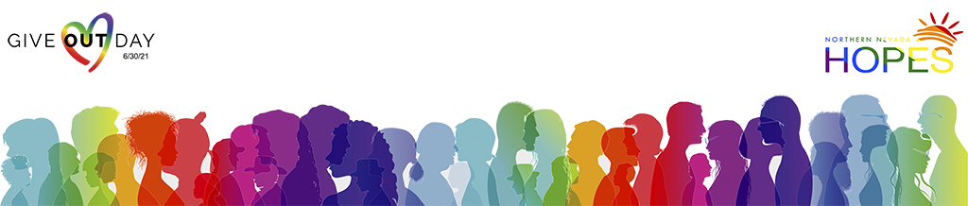

June 18, 2021

Dear Favorite Friend,

This PRIDE month as part of Give OUT Day, a month-long fundraising campaign culminating on Give OUT Day- June 30, I’m proudly raising money for Northern Nevada HOPES an organization whose vision is to build a healthier community for all.

Please consider helping me fundraise.   
  
HOPES is trying to raise $25,000 and win an additional $10,000 to connect members of the LGBTQ+ community with its one-stop-shop health and wellness services.

Some of the services they provide include:

• Primary care – we are your family doctor!  
• Hormone Replacement Therapy (HRT) and Gender Affirmation Surgery evaluations  
• LGBTQ+ behavioral health support including individual, family and group therapy  
• Testing for HIV and STI Prevention services like PrEP and PEP  
• HIV Care and wrap-around services  
• Support services like housing, medication assistance and case management  
• Referrals and payment assistance for services not provided at HOPES

**Every dollar you give will be matched! That mean you’ll have twice the impact!**

It would mean a lot to me if you made a donation, because tell your supporters why you care.

Together we can play an instrumental role in giving real HOPE.

Thank you so much for your support!

In Pride,

Your Name Here